The problem below and problems 11 and 12 at the end of Chapter 6.

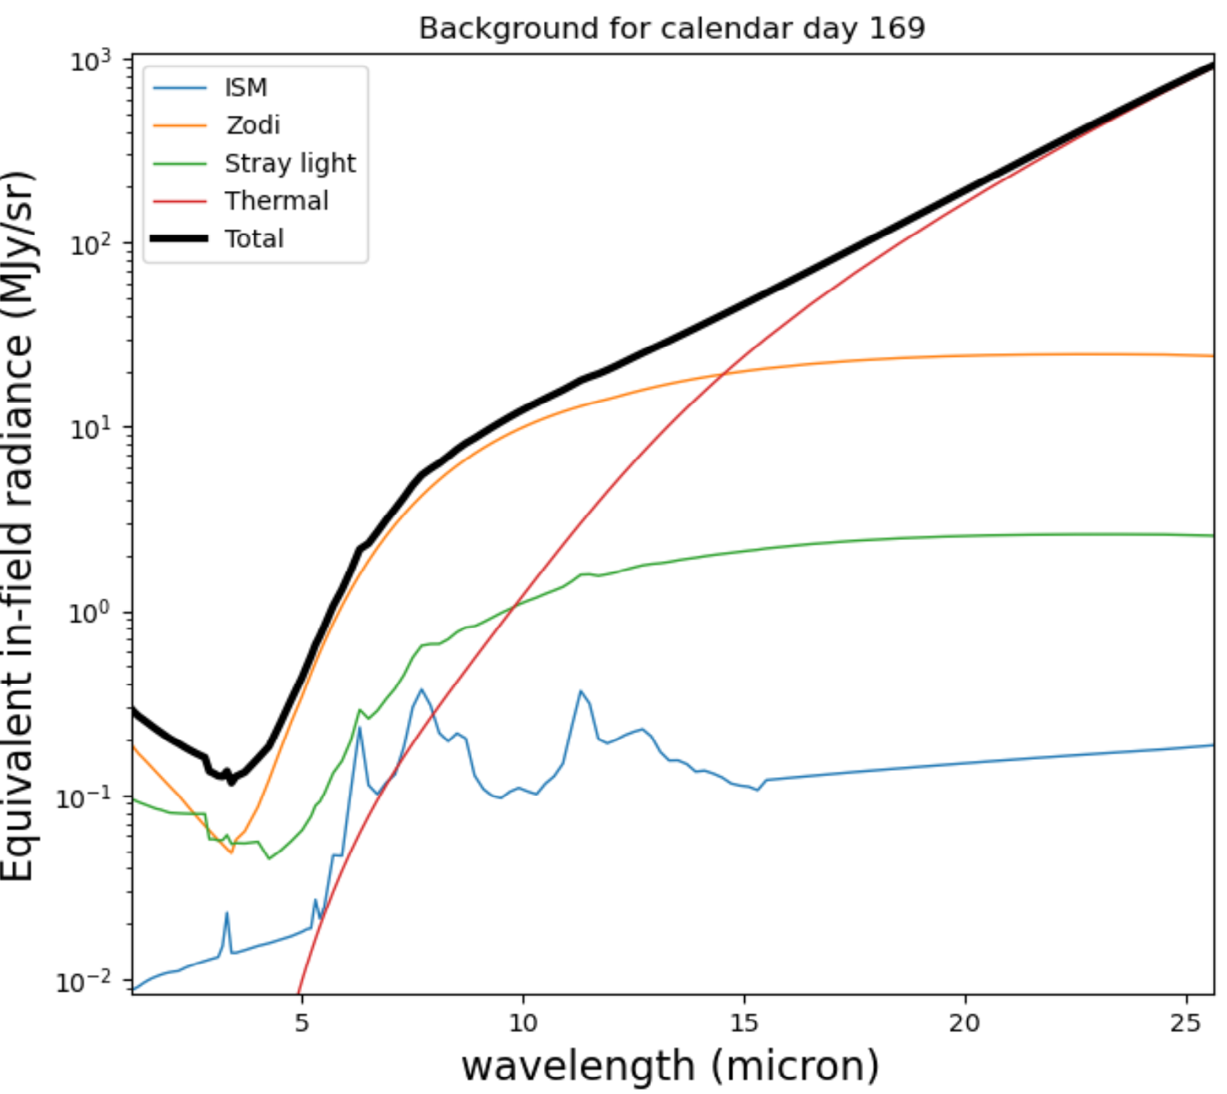

**JWST Problems**

The image above is taken from [Rigby et al. (2022)](https://arxiv.org/abs/2211.09890)

[Links to an external site.](https://arxiv.org/abs/2211.09890) and shows the various background signals that impact observations by the JWST. "ISM" is light from the interstellar medium, "Zodi" is light from the zodiacal dust in our Solar System, "Stray light" is other sources of light (e.g., the Sun), and "Thermal" is thermal emission from the telescope itself (coolers onboard JWST keep the telescope at a temperature of about 7 degrees Kelvin). The x-axis shows the wavelength of observation, and the y-axis shows the size of the background signal (in milliJanskies [10−26 W m−2 Hz−1] per steradian). Using this figure, answer the following questions:

1. Why does the thermal component of the background keep increasing beyond 5 microns wavelength? If JWST were able to observe at even longer wavelengths, beyond which wavelength would you expect the thermal component to drop off?
2. When JWST's coolers run out of coolant (many years after the propellant to stabilize the spacecraft runs out), the telescope will warm to about 30 K. How would you expect the thermal background between 5 and 25 microns to change?